Cairo University Faculty of Computers and Artificial Intelligence



**Software design specification document**

**2022**

**Project Team**

|  |  |  |
| --- | --- | --- |
| **ID** | **Name** | **Email** |
| 20201183 | Mayar Mohamed | mayarmohamedhamed12345@gmail.com |
| 20200595 | Nadeen Badr | nadeenbadr0@gmail.com |
| 20200732 | Yassmeen samy | Yassmeensamy1@gmail.com |

# Class diagram design

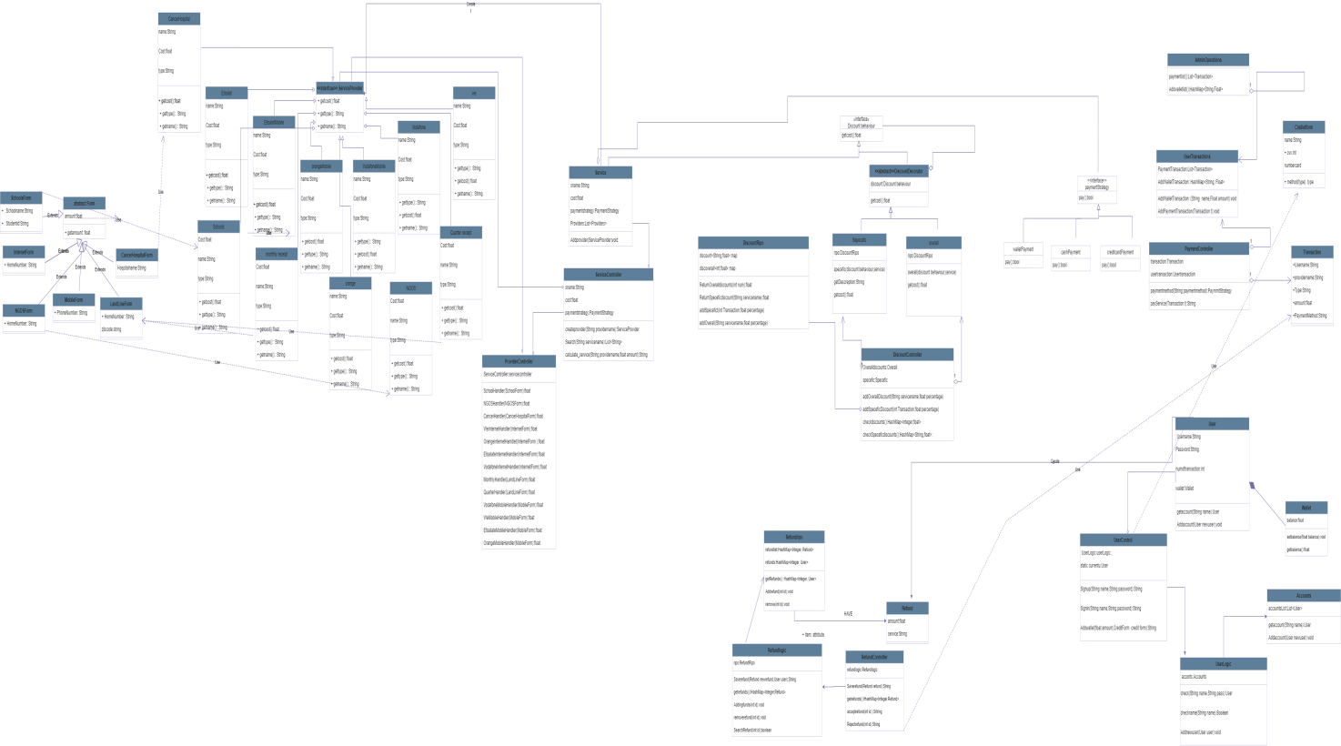

# Class diagram Explanation

* **Discount ->Decorator** because overall discounts and specific discounts for this service may apply at the same services or provider.
* **Services ->Factory** to create different providers
* **Payment ->Strategy** because it is same action but different way to do.

**Decomposition:**

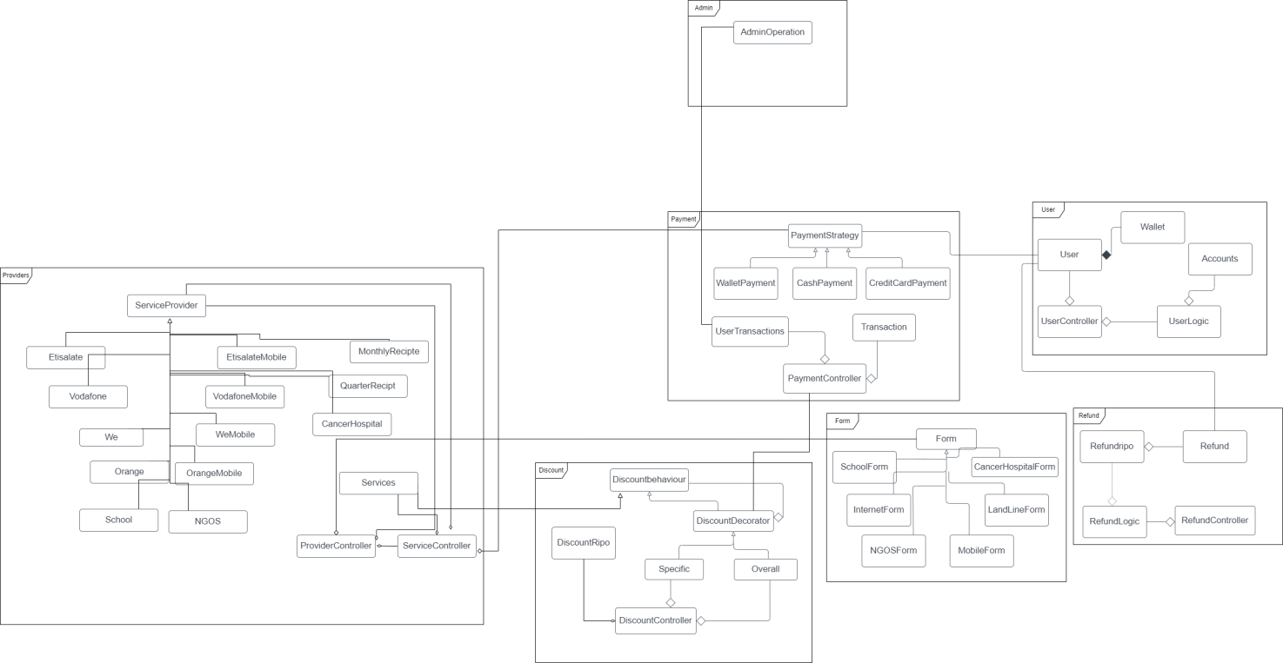

# Sequence diagram design

1-Sign In:

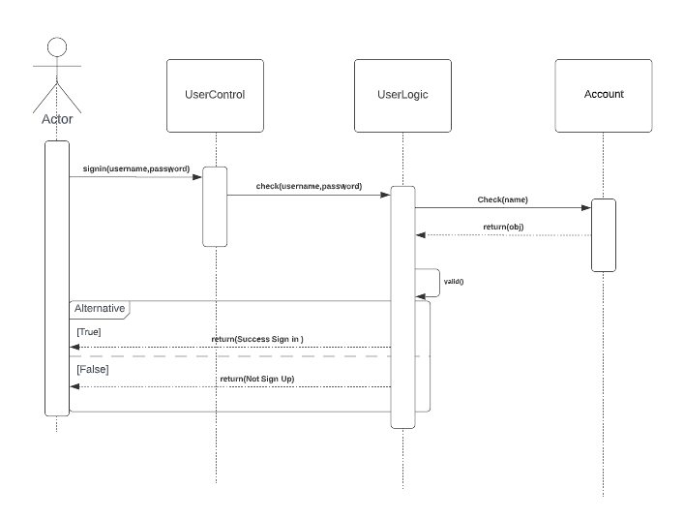

2-Refund List:

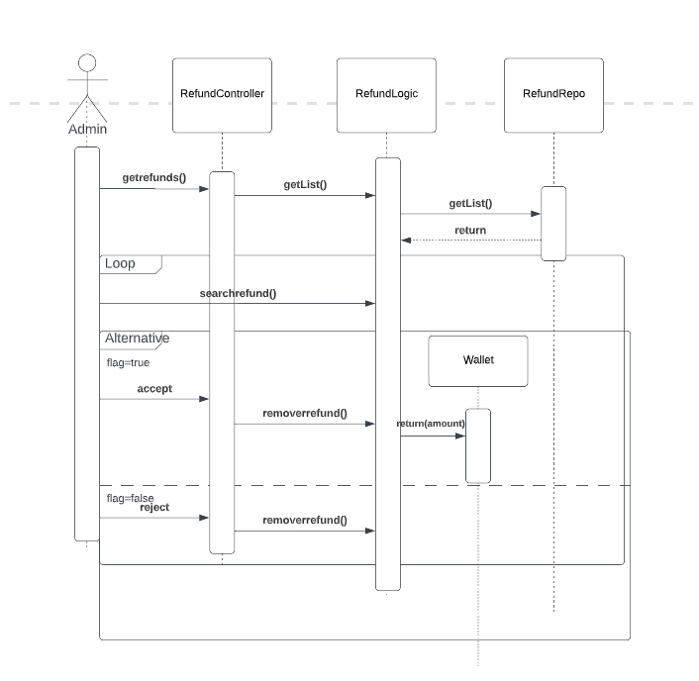

3-Discount:

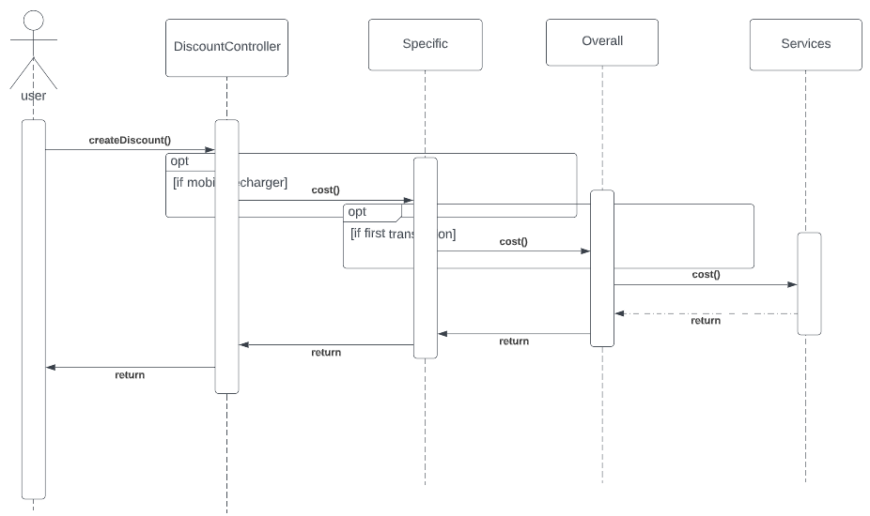

4-Payment:

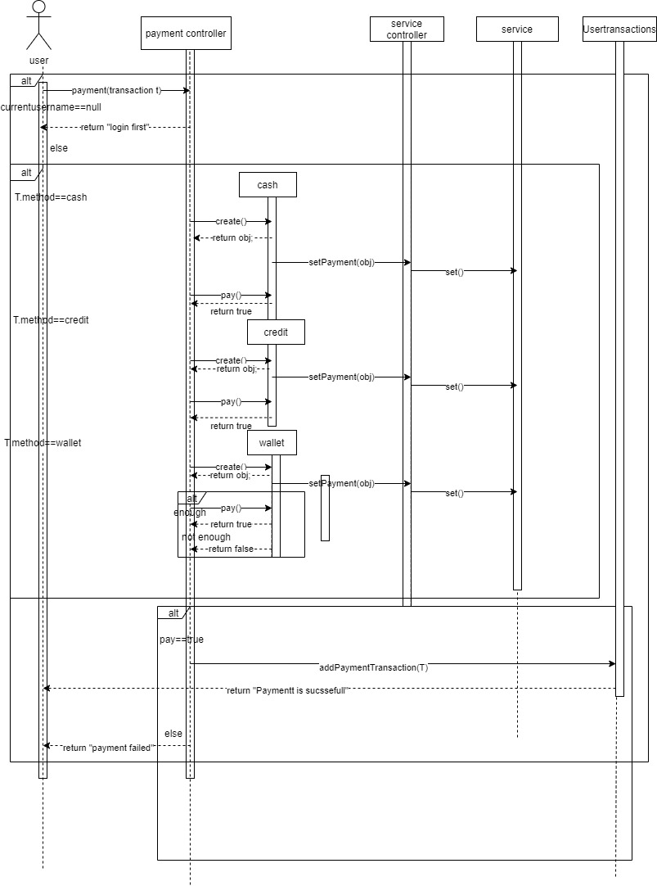

6-Refund:

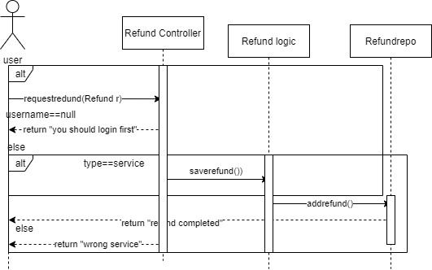

# Requirements Exposure as Web Service API

**Part 1: Exposed Postman Collection**

[**https://documenter.getpostman.com/view/25080814/2s8Z6zzBpK**](https://documenter.getpostman.com/view/25080814/2s8Z6zzBpK)

**Part 2:**

|  |  |  |
| --- | --- | --- |
| Requirement |  | Exposed API |
| User sign up |  | 1-POST(http://localhost:8080/signup)  User Post username and password and service return msg. |
| User sign in |  | 2-POST(<http://localhost:8080/signin>) User post username and password and service check if registered to give him access to log in. |
| User Payment Transaction |  | 3-POST(<http://localhost:8080/pay>) A service get amount and provider name and type and make transaction if user login before. |
| User Refund |  | 4-POST(<http://localhost:8080/requestRefund>) A services get provider name and amount and return msg to user |
| User Search |  | POST(<http://localhost:8080/search>) User post name of service and return all provider in this services. |
| User add to wallet |  | Put(<http://localhost:8080/wallet>)Inputs:amount ,Creditform(Username ,Credietnumber,cvv) |
| User check SpeceficDiscounts |  | Get(http://localhost:8080/checkSpeceficDiscount) |
| User Check overall discounts |  | Get(<http://localhost:8080/checkOverallDiscount>) |
| Admin Get List of Refund |  | GET(http://localhost:8080/getrefundlist) A service return to admin list of refund request to accept or reject |
| Admin Get List of Transactions |  | GET(http://localhost:8080/Showpaymentlist) Return to admin list of all user made transaction and detail about transaction |
| Admin Add Overall Discount |  | POST(http://localhost:8080/AddSoeceficDiscount?) Admin post number of transaction and percentage to add new discount |
| Admin Add Specific Discount |  | POST(http://localhost:8080/AddOverallDiscount) Admin post services name and percentage to add discount |
| Admin Accept Refund |  | Put(<http://localhost:8080/AcceptRefund>) Inputs: Refund id |
| Admin Reject Refund |  | Delete(<http://localhost:8080/RejectedRefund>) Inputs: Refund id |
| Admin Get list of addWallet |  | Get(http://localhost:8080/ShowAddwalletlist) |
| System calculate service |  | Get(<http://localhost:8080/calcalte_servic>?) Input:Providername ,amount |
| Form School handler |  | POST(<http://localhost:8080/Schools/Cal_Services>) User input schoolname and studentid  To return amount |
| Form NFOS handler |  | POST(<http://localhost:8080/NFOS/Cal_Services>) User input NGOSName To return amount |
| Form Cancer Hospital handler |  | POST(<http://localhost:8080/CancerHospital/Cal_Services>) User input HospitalName and transfernumber To return amount |
| Form Monthly Receipt handler |  | POST(<http://localhost:8080/MonthlyReceipt/Cal_Services>)User input zipcode and homenumber |
| Form Quarter Receipt handler |  | POST(<http://localhost:8080/QuarterReceipt/Cal_Services>) User input zipcode and homenumber |
| Form We Internet handler |  | POST(<http://localhost:8080/WeInternet/Cal_Services>) User input homenumber and zipcode and return amount |
| Form Orange Internet handler |  | POST(<http://localhost:8080/OrangeInternet/Cal_Services>)User input homenumber and zipcode and return amount |
| Form Etisalate Internet handler |  | POST(<http://localhost:8080/EtisalateInternet/Cal_Services>)User input homenumber and zipcode and return amount |
| Form Vodafone Internet handler |  | POST(<http://localhost:8080/VodafoneInternet/Cal_Services>)User input homenumber and zipcode and return amount |
| Form We Mobile handler |  | POST(<http://localhost:8080/WeMOBILE/Cal_Services>)User input phonenumber and return amount |
| Form Orange Mobile handler |  | POST(<http://localhost:8080/OrangeMobiles/Cal_Services>)User input phonenumber and return amount |
| Form Etisalate Mobile handler |  | POST(<http://localhost:8080/EtisalateMobile/Cal_Services>)User input phonenumber and return amount |
| Form Vodafone Mobile handler |  | POST(<http://localhost:8080/VodafoneMobiles/Cal_Services>)User input phonenumber and return amount |

# Github repository link

* [**https://github.com/Nadeen-Badr/ASW-Project-Phase1**](https://github.com/Nadeen-Badr/ASW-Project-Phase1)